1. Specifications

Pressure Limits: 30 PSI (2.067 bar) continuous to either pressure connection; 50 PSI (3.455 bar) surge.
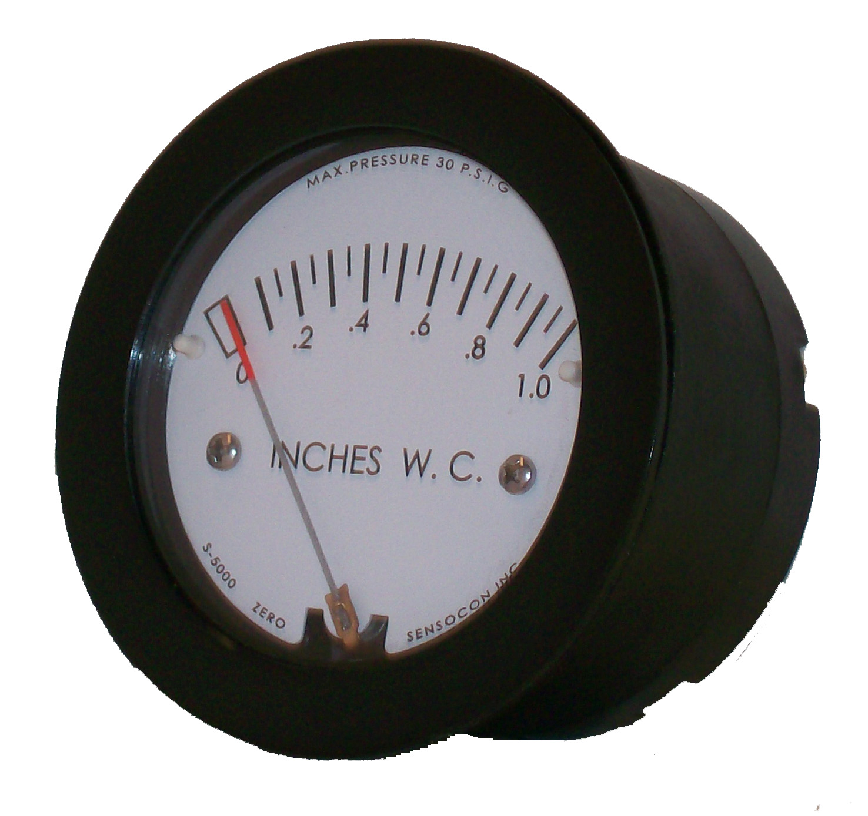
Media Compatibility: Air and compatible non corrosive gasses
Accuracy: +/- 5% full scale at 70°F (21°C)
Temperature Range: 20 to 120°F (-6.7 to 49°C)
Process Connections: barbed connections for 3/16” I.D. tubing
Housing: Glass-filled nylon, polycarbonate cover.
Mounting: Vertical, consult factory for other postitions
Weight: 6 oz (170 g)

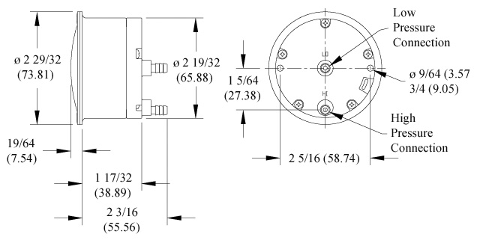
2. Installation

- Upon receipt please inspect the instrument for the intended application pressure range.
- Install the instrument in a location free from excessive vibration and where the ambient temperature will be between 20°F and 120°F (-6.7°C to 49°C)
- All standard P5000 gauges are calibrated in the vertical position. To maintain the specified accuracy, the gauge must be mounted in the vertical position.

3. Mounting

Surface Mounting
Drill two 5/32” (3.97 mm) holes on a horizontal line, 2 1/3” (59.26 mm) apart for mounting screws. Drill two 7/16” (11.11 mm) holes 1 1/32” (26.19 mm) apart on a vertical line for pressure connections. Install mounting studs in back of the gauge, insert through holes in the panel, and secure with hex nuts provided.
Flush or Panel Mounting
Cut an opening in the panel 2 5/8” in diameter. Install the mounting studs in the back of the gauge, insert the gauge in the panel, and place the bracket over the studs. Use the nuts provided on the mounting studs to fasten the gauge in place.

4. Pressure Connections

Positive Pressure Measurement: Connect the pressure tubing to the “HI” port and the “LO” port should be open to atmospheric pressure.

Negative Pressure Measurement: Connect the pressure tubing to the “LO” port and the “HI” port should be open to atmospheric pressure.

Differential Pressure Measurement: Connect the pressure tubing with the highest pressure to the “HI” port and connect the pressure tubing with the lowest pressure to the “LO” port.

5. Zero Adjustment

If it is necessary to re-zero the gauge, you must first remove the front cover. This can be done by firmly holding the gauge in one hand and unscrewing the front cover with the palm of the other hand in a counterclockwise direction.
Use the zero-adjust screw located behind the scale at the location marked “zero” and adjust the pointer to zero while both the HI and LO pressure ports are open to atmosphere and the gauge is oriented in the final mounting position.

6. Maintenance

No special maintenance is required other than keeping the lens and case exterior clean.

